Assignment #2 SAS Programming 1 by Joshua Troup

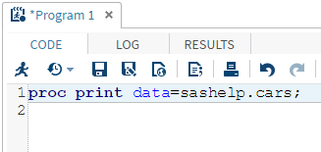

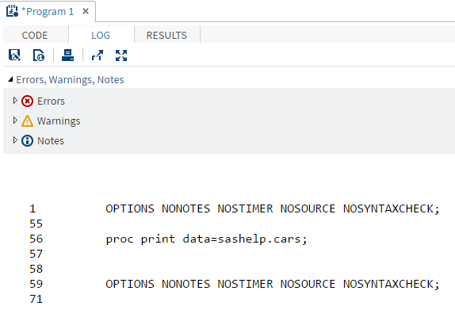

1. Code to create program to develop Car Table with 0 Errors.
2. Enclosed in PDF file uploaded separately
3. 428 Observations & 15 Variables